Example # 01
The following shows the formula structure and applies it to a medical diagnosis scenario (probability of having a sore throat given a positive strep test).
To make it clearer in words:
🔹 Bayes’ Theorem Structure
[ P(A|B) = {P(B|A) * P(A)} / {P(B)}
- Prior (P(A)) → Initial belief before seeing evidence
- Likelihood (P(B|A)) → Probability of evidence given the hypothesis
- Evidence (P(B)) → Overall probability of the evidence
- Posterior (P(A|B)) → Updated belief after seeing evidence

🔹 Real-Time Example: Medical Test
Suppose we want the probability that a patient has a disease given a positive test result.
- Hypothesis (A): Patient has the disease
- Evidence (B): Test result is positive
Bayes’ Theorem tells us:
[ P({Disease | Positive Test}) = {P{Positive Test | Disease}) * P{Disease})} / {P{Positive Test})}
- P(Positive Test | Disease): Accuracy of the test (sensitivity)
- P(Disease): Prior probability (prevalence of disease in population)
- P(Positive Test): Probability of testing positive overall (both true positives and false positives)
- P(Disease | Positive Test): Updated probability that the patient actually has the disease

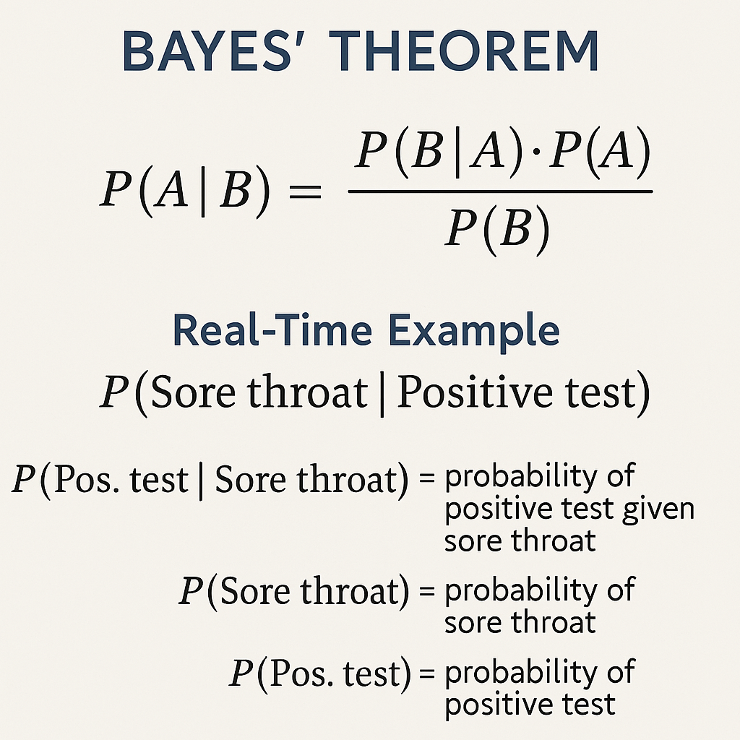

Numerical Example: Disease Diagnosis
Let’s say:
- P(Disease) = 1% → Only 1 in 100 people have the disease.
- P(Positive Test Disease) = 99% → Test is very accurate for detecting disease.
- P(Positive Test No Disease) = 5% → False positive rate.
We want to find:
P(Disease | Positive Test) → Probability that someone actually has the disease given a positive test.
Apply Bayes’ Theorem
P(Disease|Positive)={P(Positive|Disease) * P(Disease)} / {P(Positive)}
Where:
- P(Positive) = P(Positive Disease) × P(Disease) + P(Positive No Disease) × P(No Disease)
=(0.99 * 0.01) + (0.05 * 0.99) = 0.0099+0.0495 = 0.0594
Now plug into Bayes’ formula:
P(Disease|Positive)={0.99 * 0.01} / {0.0594} = {0.0099} / {0.0594} = 0.1667 (approx..)

Example # 02
Let’s explore another real-time example of Bayes’ Theorem, this time in the context of spam email detection — a classic use case in machine learning and data science.
📧 Real-Time Example: Spam Email Detection
Suppose we want to calculate the probability that an email is spam given that it contains the word “free”.
Known Probabilities:
- P(Spam) = 20% → 20% of all emails are spam.
- P(“Free” Spam) = 60% → 60% of spam emails contain the word “free”.
- P(“Free”) = 30% → 30% of all emails contain the word “free”.
Apply Bayes’ Theorem
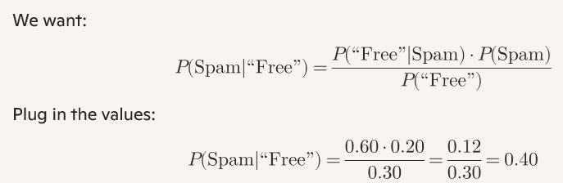

Conclusion:
If an email contains the word “free”, there’s a 40% chance it’s spam — even though only 20% of all emails are spam. That’s the power of conditional probability.

# Bayes' Theorem Demonstration in Python

# Formula:
# P(A|B) = [ P(B|A) * P(A) ] / P(B)

# Definitions:
# Prior (P(A)) → Initial belief before seeing evidence
# Likelihood (P(B|A))→ Probability of evidence given the hypothesis
# Evidence (P(B)) → Overall probability of the evidence
# Posterior (P(A|B)) → Updated belief after seeing evidence

def bayes_theorem(prior, likelihood, evidence):
"""
Calculate posterior probability using Bayes' Theorem.
"""
posterior = (likelihood * prior) / evidence
return posterior

# Example Scenario: Medical Diagnosis
# Hypothesis (A): Patient has a sore throat due to strep infection
# Evidence (B): Positive strep test

# Assumptions (for demonstration purposes):
prior = 0.10 # Prior: 10% of patients have strep infection causing sore throat
likelihood = 0.95 # Likelihood: 95% chance test is positive if patient has strep
false_positive = 0.05 # 5% chance test is positive even without strep
prevalence_no_strep = 0.90 # 90% patients do not have strep

# Evidence: Overall probability of a positive test
evidence = (likelihood * prior) + (false_positive * prevalence_no_strep)

# Posterior: Probability of having strep given a positive test
posterior = bayes_theorem(prior, likelihood, evidence)

# Display results
print("🔹 Bayes' Theorem Structure")
print("P(A|B) = [ P(B|A) * P(A) ] / P(B)\n")

print("Prior (P(A)) =", prior)
print("Likelihood (P(B|A))=", likelihood)
print("Evidence (P(B)) =", round(evidence, 4))
print("Posterior (P(A|B)) =", round(posterior, 4))

print("\nInterpretation:")
print(f"Given a positive strep test, the probability of having a sore throat due to strep is {posterior:.2%}.")

Explanation of the Example
- Prior (P(A)): 10% of patients have strep infection causing sore throat.
- Likelihood (P(BA)): If the patient has strep, the test is positive 95% of the time.
- Evidence (P(B)): Probability of a positive test overall (both true positives and false positives).
- Posterior (P(AB)): Updated probability that the patient has strep given the positive test result.

